April 24, 2012
Environmental Energy Technologies Division
SAFETY ALERT
HOT PLATE FAILURE
We recently experienced an overheating issue with a laboratory hot plate (VWR digital hot plate/stirrer). After heating a sample situated inside an oil bath, the hot plate heater was switched off. By the next morning, the oil had boiled off. The hot plate was found cool and had automatically shut-off due to an over-temperature condition. The hot plate was immediately taken out of service and sent back to the manufacturer for replacement and evaluation of any defects. The primary cause of the overheating may have been due to a temperature probe cable coming in contact with the hot plate surface and partially melting causing a short.
We should look at this incident as a valuable “lesson learned” and keep in mind the following precautions for all hot plates currently in use in EETD lab areas:
- Always turn-off the hot plate when it is not in use. The hot plate main power switch should be turned-off in addition to the heater power switch.
- Ensure that electrical cords and temperature sensor probe wires do not come in contact with the hot plate surface. A means of positively securing cables so that they cannot move should be provided.
- Older non-digital hot plates should be provided with a “power-on” indicator light and a temperature control knob which stops at a clearly marked “off” position.
- Periodically test the function of the “off switch” on each hot plate to verify it works and it quickly cools. Any unit that fails this test should be immediately taken out of service.
- Avoid unattended use of hot plates when possible. If unattended heating cannot be avoided, consider an additional feedback system such as pre-set timers or automatic high temperature shut-off.
- Do not store combustible materials or flammable liquids near hot plates such that a spill could come in contact with the unit. Minimize quantities stored and segregate through the use of trays. Provide secondary containment for any flammable liquids being heated.
- Do not use hot plates in flammable atmospheres. In the event that flammable liquids must be heated, there must be sufficient exhaust flow near the hot plate. Hot plates are NOT explosion proof or intrinsically safe.
- Do not use the high temperature setting to heat low boiling point liquids. Allow liquids to heat gradually on low or medium heat settings.
- Always use a hot plate that is larger than the container being heated.
- Only use heat resistant containers such as borosilicate glassware on hot plates. Do not use plastic containers as these can melt. (See Lessons Learned, LL08-0033, at https://isswprod.lbl.gov/lessonslearned/start.aspx)
- Regularly check hot plate surfaces for damage such as chipping or etching. Also check for electrical damage. If any damage is identified, immediately take the unit out of service and lock/tag the power cord to prevent use until repairs are made. If the hot plate is being discarded, unplug and cut the cord to prevent reuse.
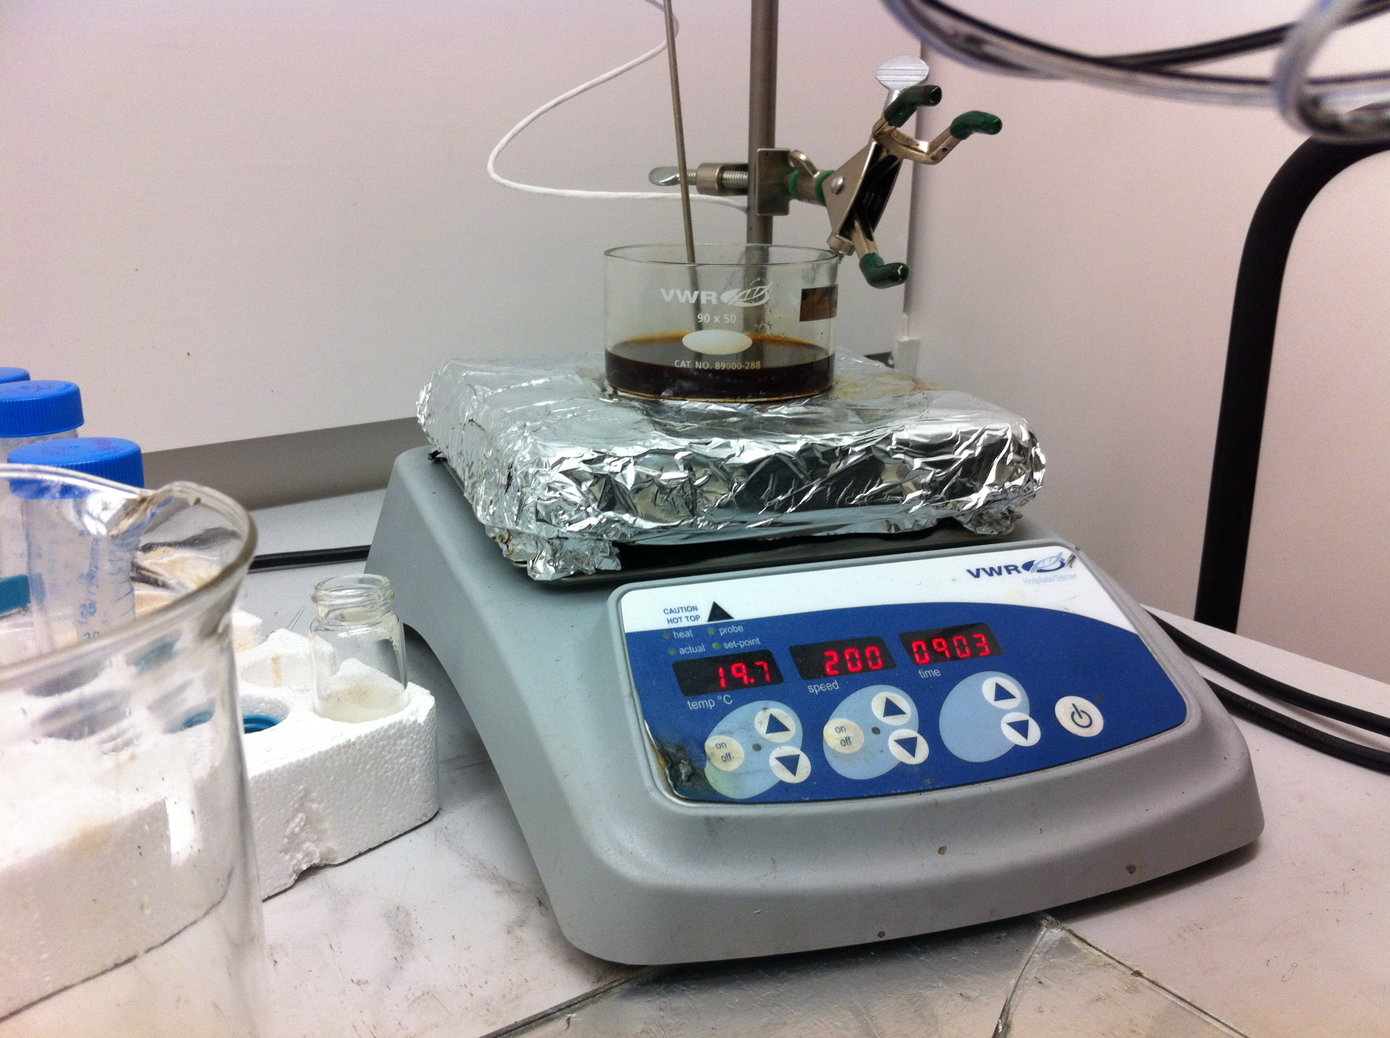
Note separate “heater off” (red arrow) and “main power off” (green arrow) controls. White cord is to a temperature probe. In this example, the cord is situated away from the hot plate surface (yellow arrow).
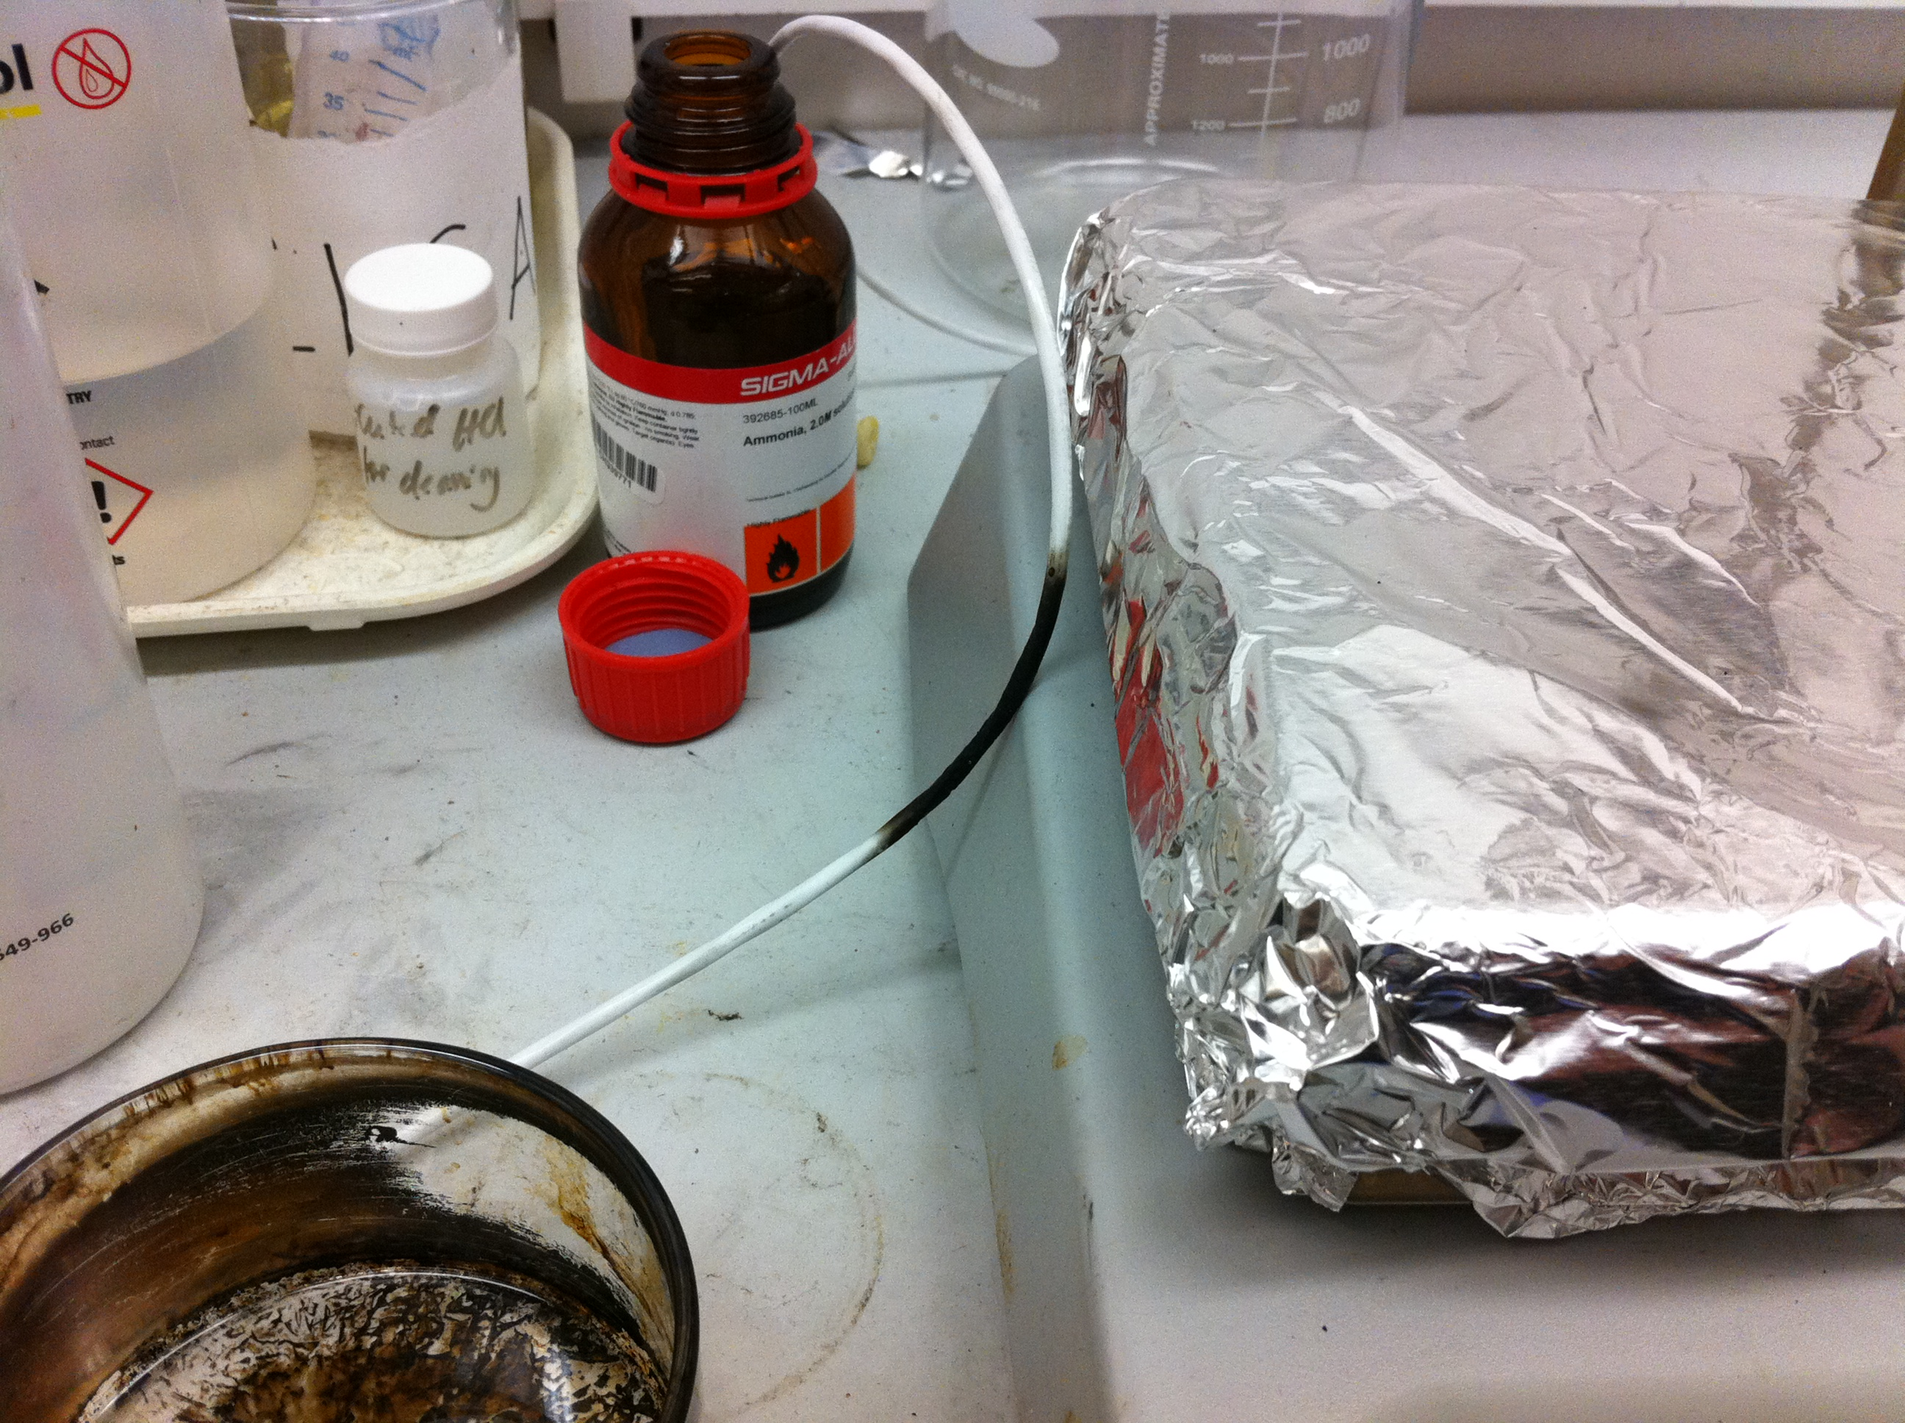 Lab fires involving hot plates do happen. Visit http://www.lbl.gov/ehs/Lessons/pdf/FinalHotPlateLL.pdf to learn of another incident at LBNL.
Note burned temperature probe wire (red arrow) and residues left in the boiled off oil bath (yellow arrow).

